**CSA-0908 JAVA PROGRAMMING**

**EASY PROGRAMS**

1.Two Sum

import java.util.HashMap;

import java.util.Map;

public class R192211470 {

public static int[] twoSum(int[] nums, int target) {

Map<Integer, Integer> map = new HashMap<>();

for (int i = 0; i < nums.length; i++) {

int complement = target - nums[i];

if (map.containsKey(complement)) {

return new int[] { map.get(complement), i };

}

map.put(nums[i], i);

}

throw new IllegalArgumentException("No two sum solution");

}

public static void main(String[] args) {

int[] nums1 = {2, 7, 11, 15};

int target1 = 9;

int[] result1 = twoSum(nums1, target1);

System.out.println("Output: [" + result1[0] + ", " + result1[1] + "]");

int[] nums2 = {3, 2, 4};

int target2 = 6;

int[] result2 = twoSum(nums2, target2);

System.out.println("Output: [" + result2[0] + ", " + result2[1] + "]");

int[] nums3 = {3, 3};

int target3 = 6;

int[] result3 = twoSum(nums3, target3);

System.out.println("Output: [" + result3[0] + ", " + result3[1] + "]");

}

}

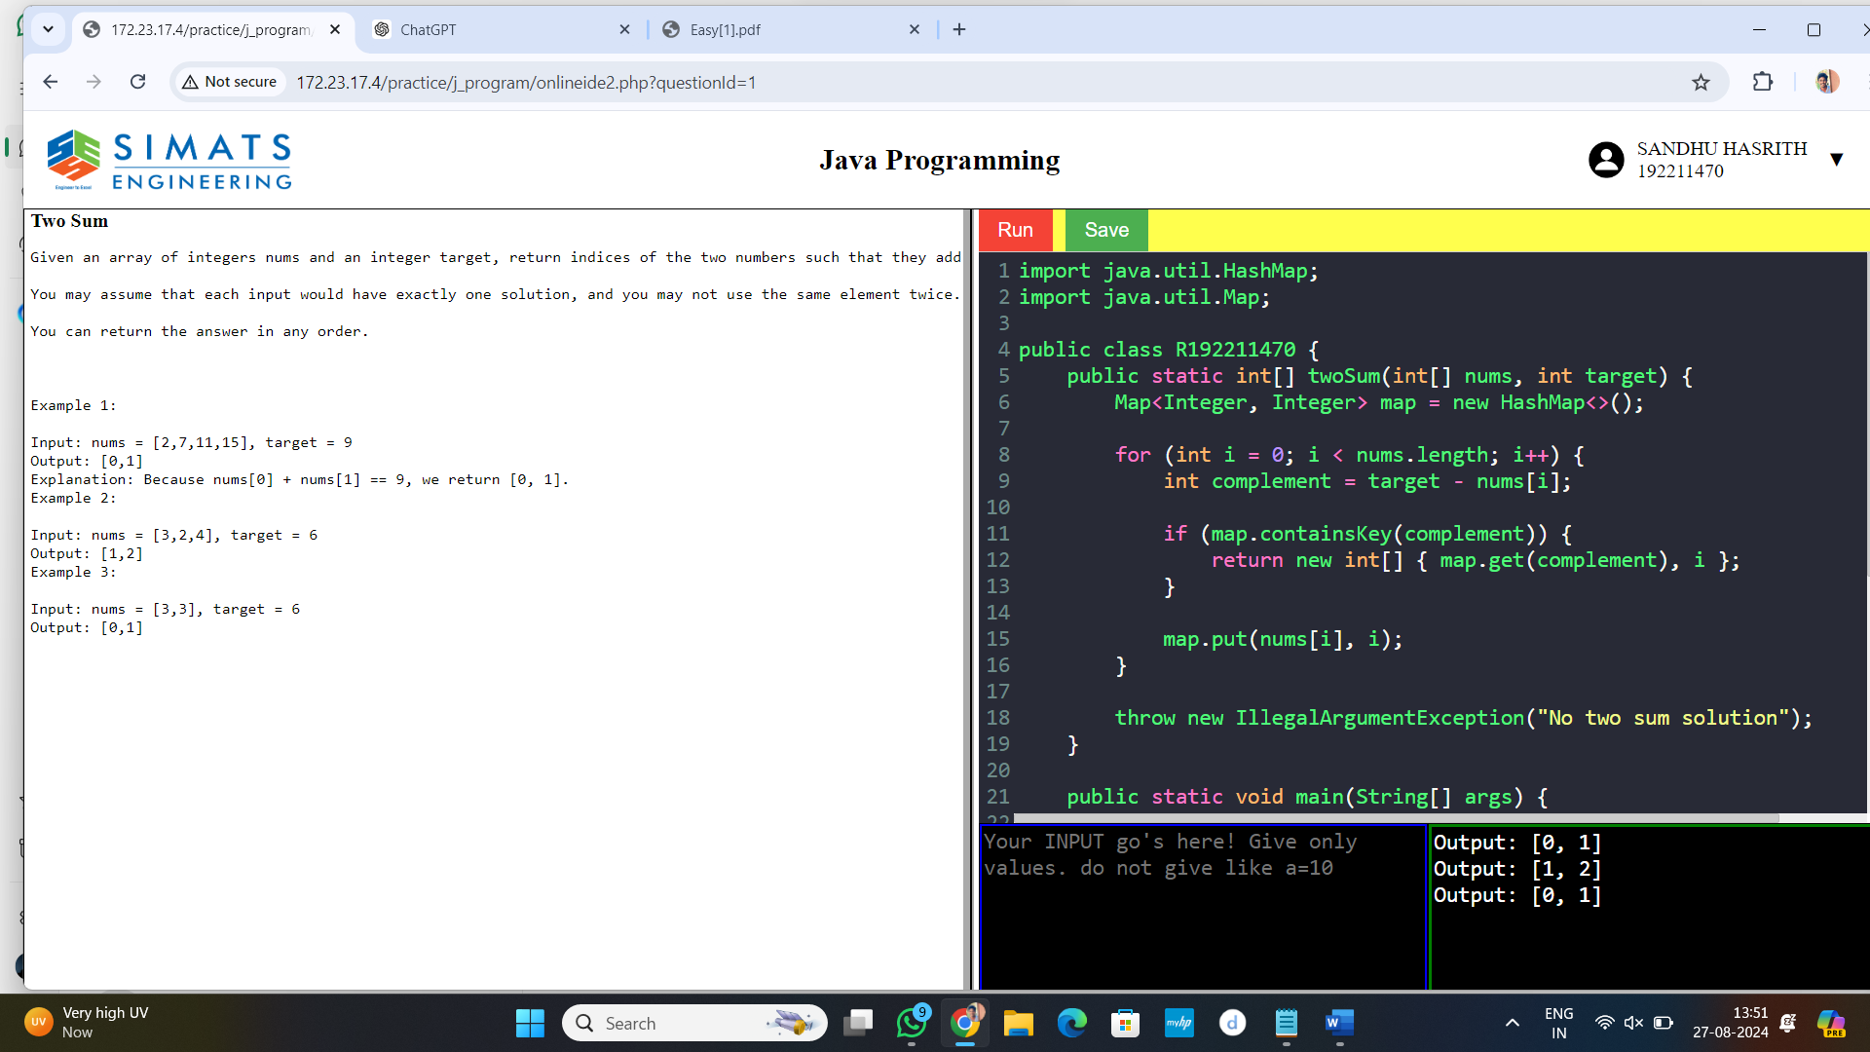

2.Valid Palindrome

public class R192211470 {

public static boolean isPalindrome(int x) {

if (x < 0) {

return false;

}

int original = x;

int reversed = 0;

while (x != 0) {

int digit = x % 10;

reversed = reversed * 10 + digit;

x /= 10;

}

return original == reversed;

}

public static void main(String[] args) {

int x1 = 121;

System.out.println(x1 + " is a palindrome: " + isPalindrome(x1));

int x2 = -121;

System.out.println(x2 + " is a palindrome: " + isPalindrome(x2));

int x3 = 10;

System.out.println(x3 + " is a palindrome: " + isPalindrome(x3));

int x4 = 12321;

System.out.println(x4 + " is a palindrome: " + isPalindrome(x4));

}

}

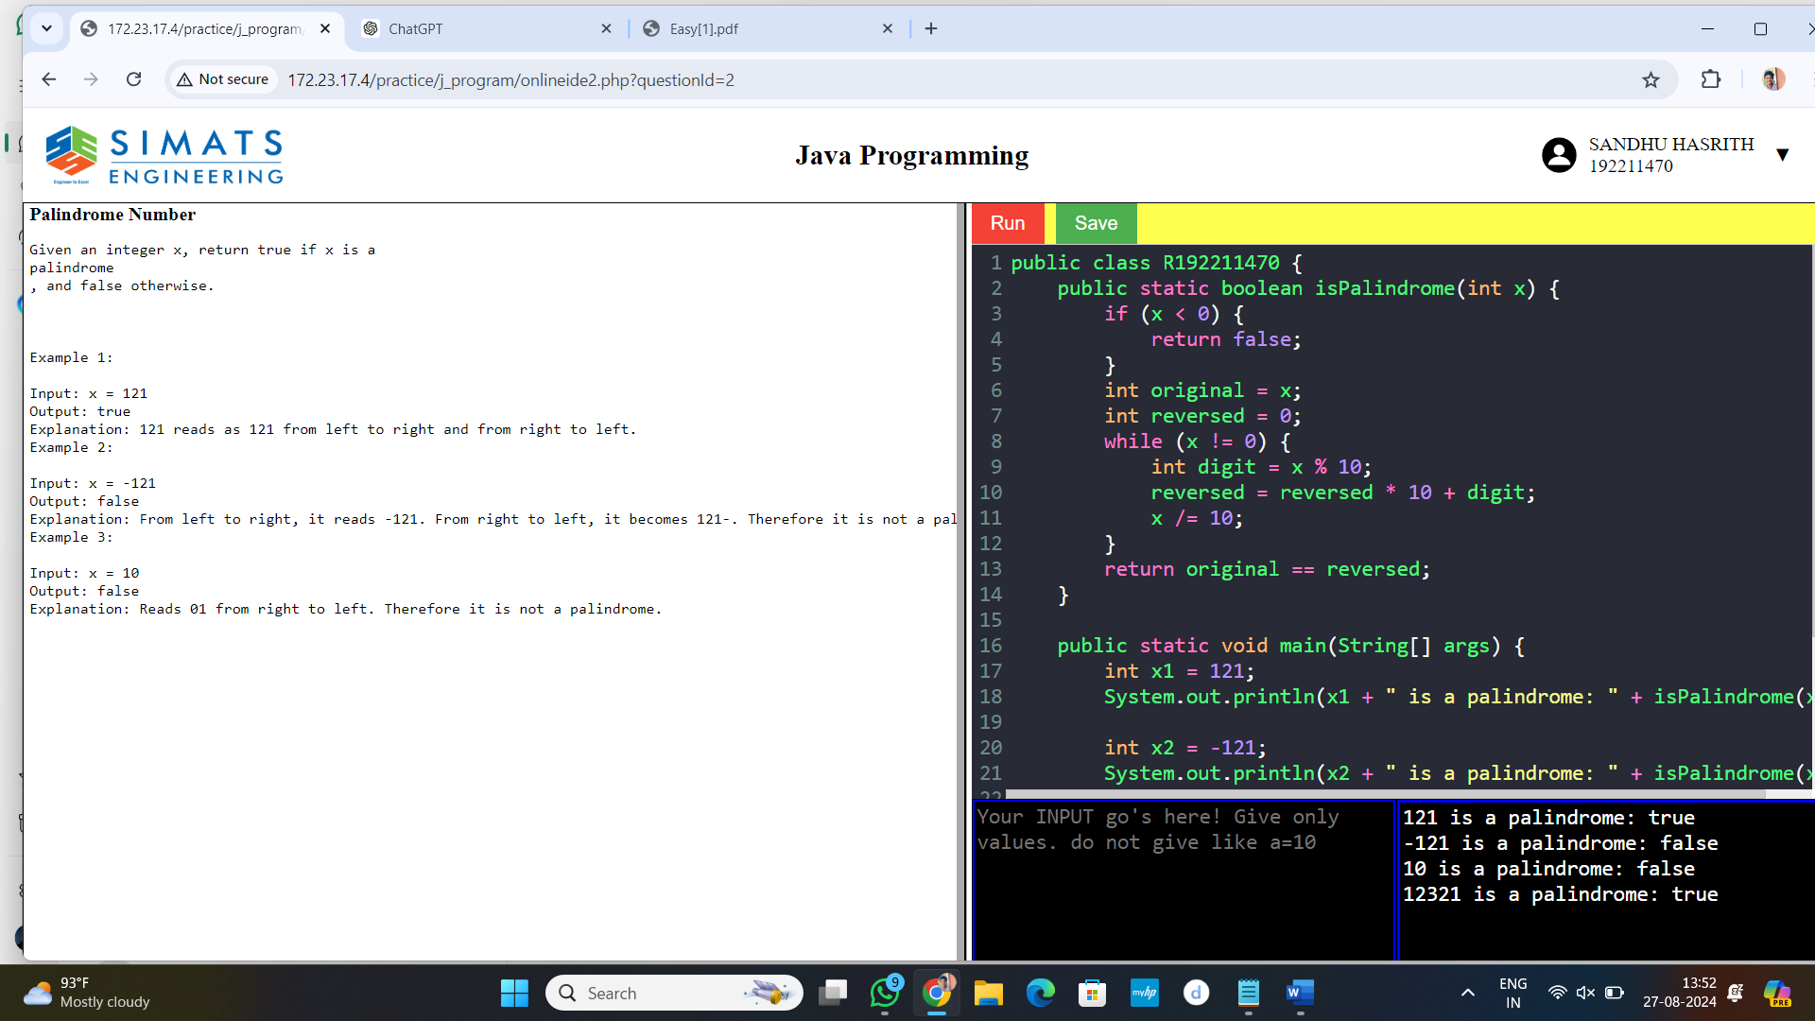

3. longest Common Prefix

public class R192211470 {

public static String longestCommonPrefix(String[] strs) {

if (strs == null || strs.length == 0) {

return "";

}

String prefix = strs[0];

for (int i = 1; i < strs.length; i++) {

while (strs[i].indexOf(prefix) != 0) {

prefix = prefix.substring(0, prefix.length() - 1);

if (prefix.isEmpty()) {

return "";

}

}

}

return prefix;

}

public static void main(String[] args) {

String[] strs1 = {"flower", "flow", "flight"};

System.out.println("Longest Common Prefix: " + longestCommonPrefix(strs1)); // Output: "fl"

String[] strs2 = {"dog", "racecar", "car"};

System.out.println("Longest Common Prefix: " + longestCommonPrefix(strs2));

String[] strs3 = {"interspecies", "interstellar", "interstate"};

System.out.println("Longest Common Prefix: " + longestCommonPrefix(strs3));

String[] strs4 = {"throne", "throne"};

System.out.println("Longest Common Prefix: " + longestCommonPrefix(strs4));

String[] strs5 = {"apple", "ape", "april"};

System.out.println("Longest Common Prefix: " + longestCommonPrefix(strs5));

}

} 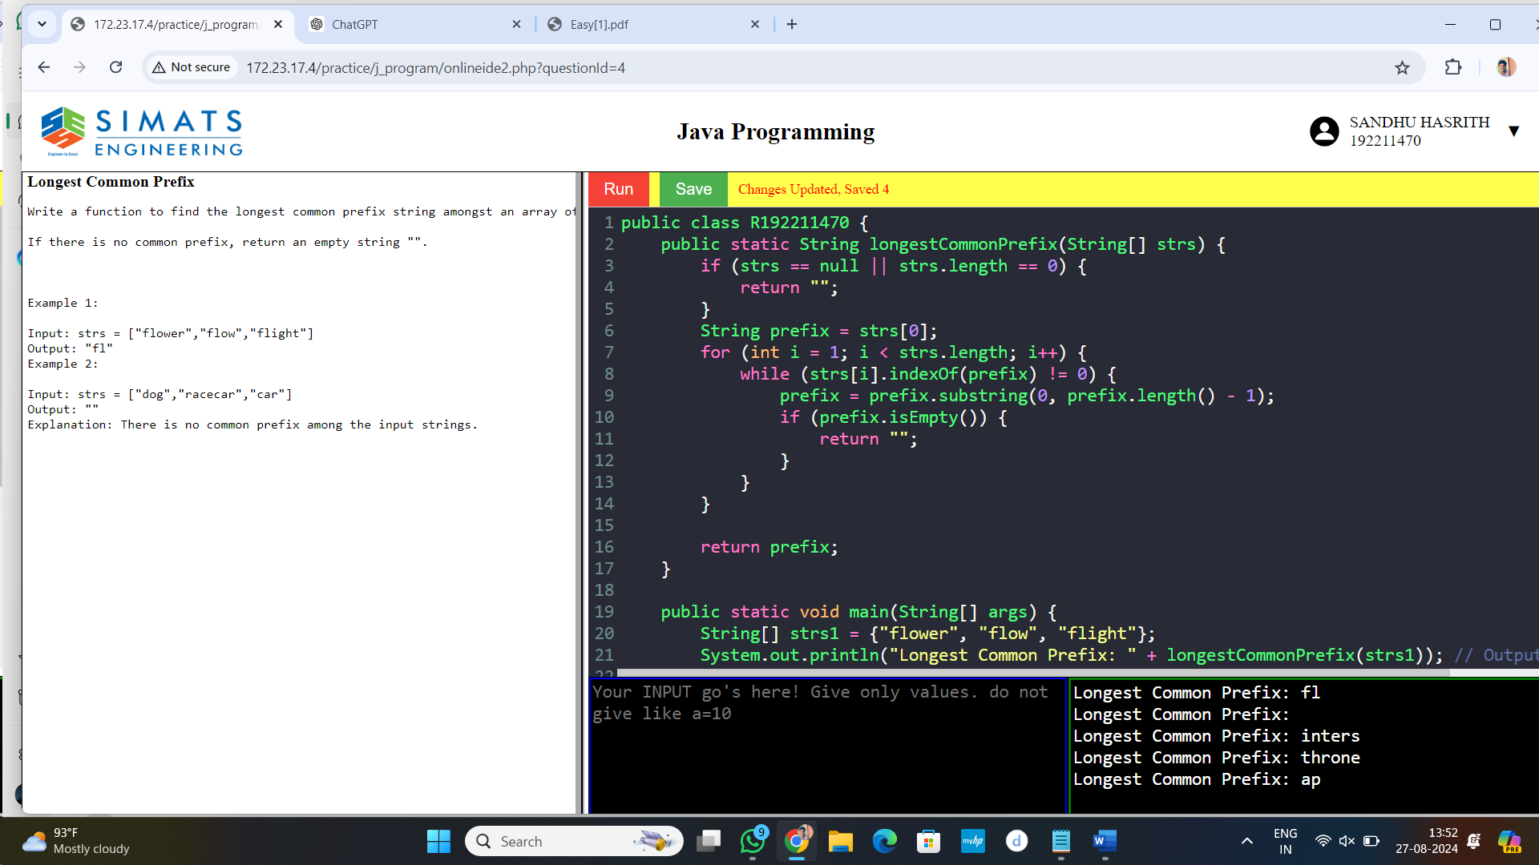

4. Merge two lists

class ListNode {

int val;

ListNode next;

ListNode(int val) { this.val = val; }

}

public class R192211470 {

public static ListNode mergeTwoLists(ListNode list1, ListNode list2) {

ListNode dummy = new ListNode(-1);

ListNode current = dummy;

while (list1 != null && list2 != null) {

if (list1.val <= list2.val) {

current.next = list1;

list1 = list1.next;

} else {

current.next = list2;

list2 = list2.next;

}

current = current.next;

}

if (list1 != null) {

current.next = list1;

} else if (list2 != null) {

current.next = list2;

}

return dummy.next;

}

public static void printList(ListNode head) {

while (head != null) {

System.out.print(head.val + " ");

head = head.next;

}

System.out.println();

}

public static void main(String[] args) {

ListNode list1 = new ListNode(1);

list1.next = new ListNode(2);

list1.next.next = new ListNode(4);

ListNode list2 = new ListNode(1);

list2.next = new ListNode(3);

list2.next.next = new ListNode(4);

ListNode mergedList = mergeTwoLists(list1, list2);

System.out.print("Merged List: ");

printList(mergedList);

}

}

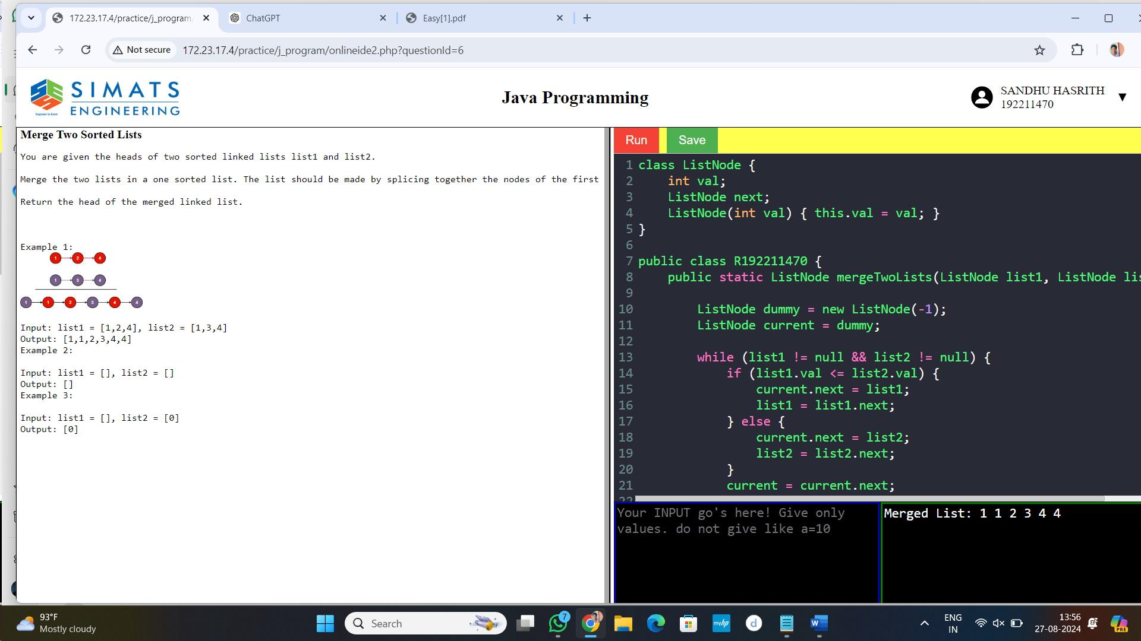

5. 5. Find the LCM and GCD of n numbers?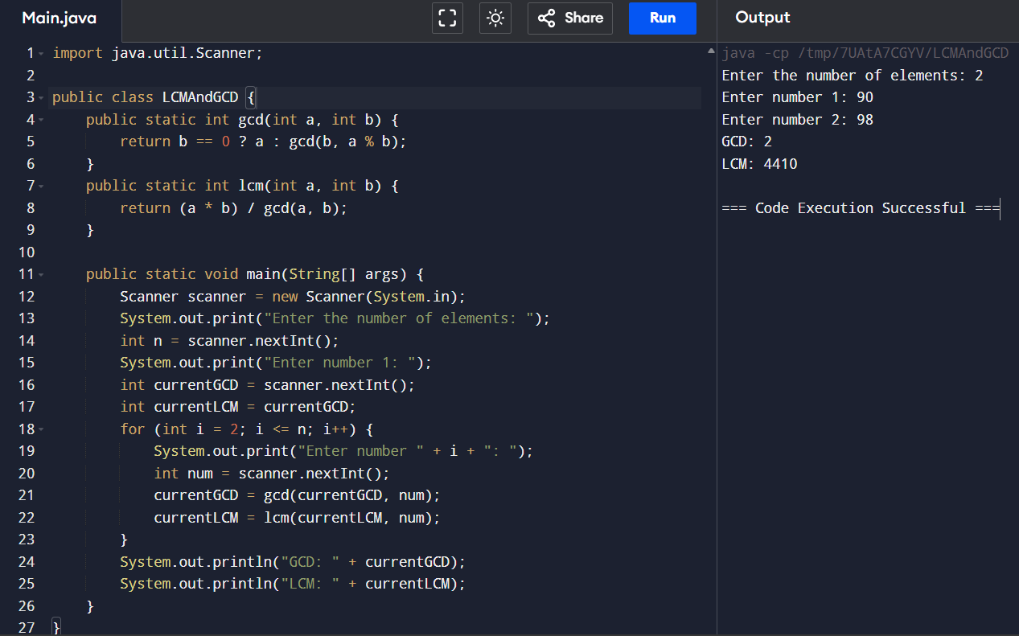

6. Write a program to print Right Triangle Star Pattern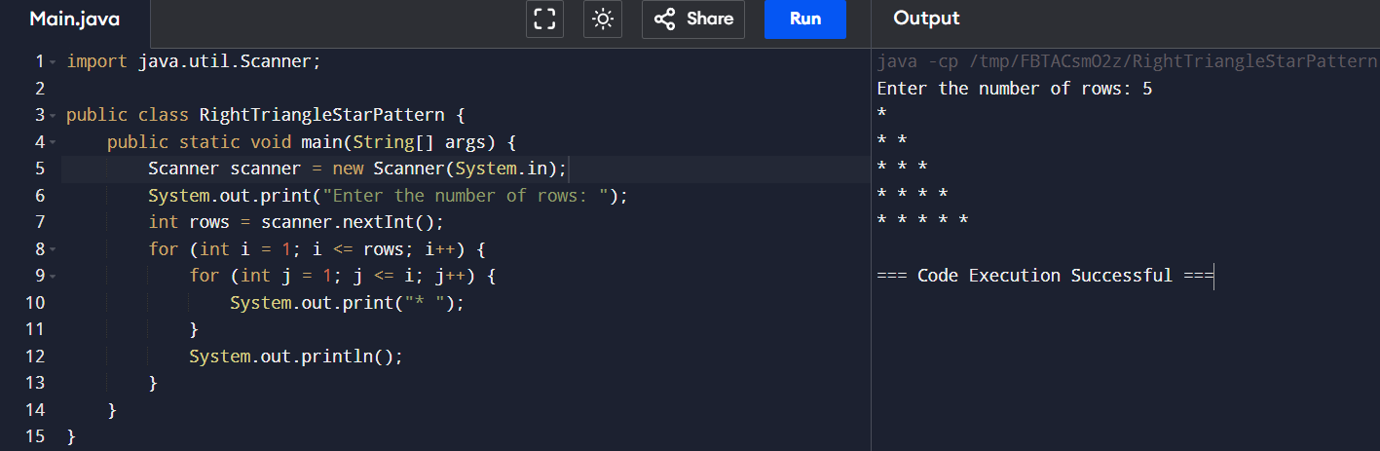

7.Write a program to print the below pattern?

1

1 1

1 2 1

1 3 3 1

1 4 6 4 1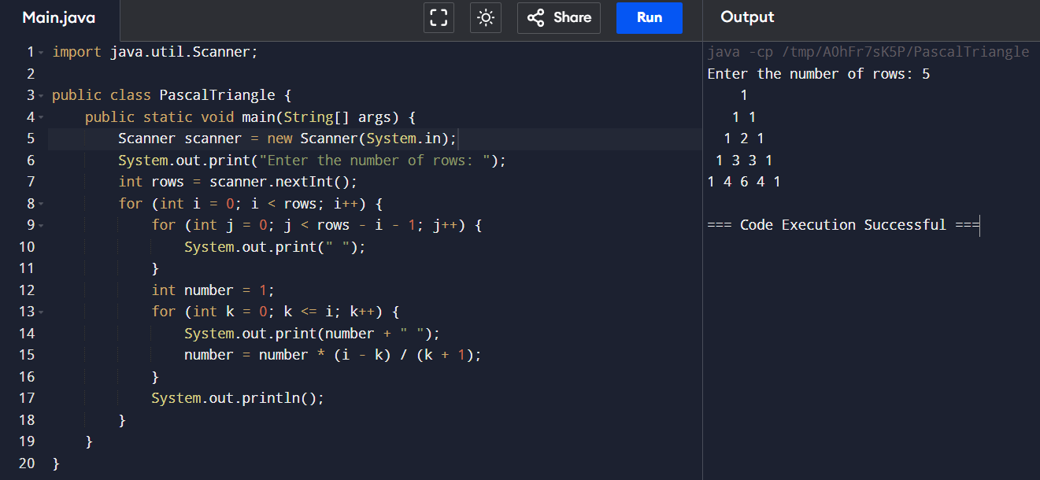

8. Write a program using function to calculate the simple interest. Suppose the customer is a senior citizen. He is being offered 12 percent rate of interest; for all other customers, the ROI is 10 percent.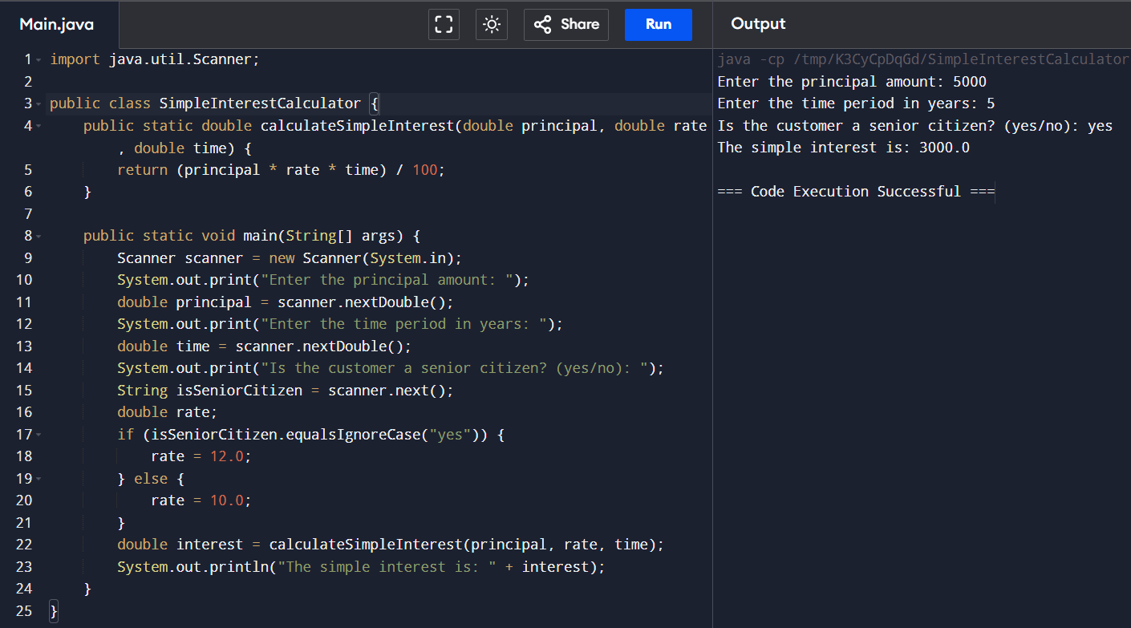

9. Java Program to Find Even Sum of Fibonacci Series Till number N?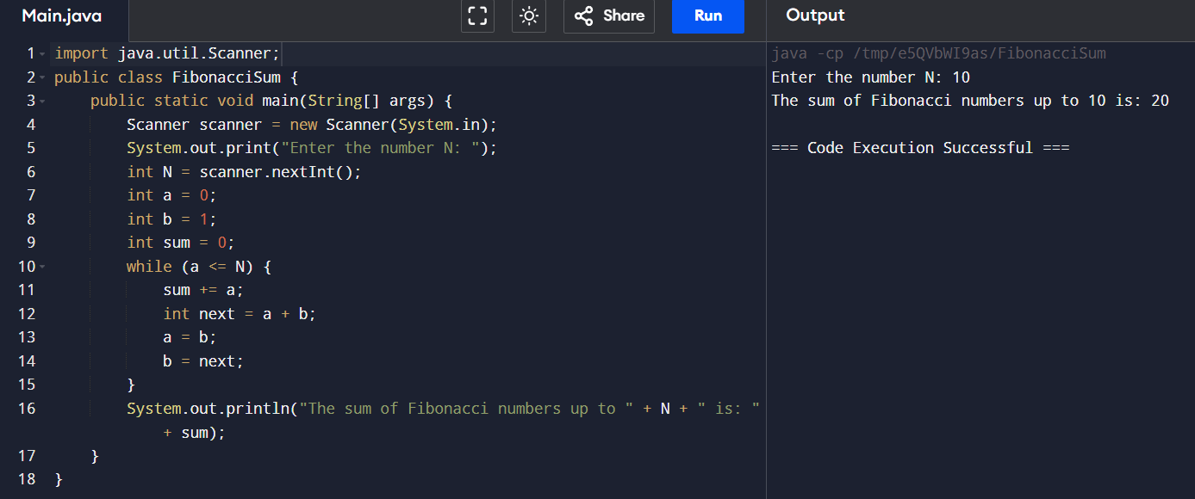

10. Write a program to print the numbers from M to N by skipping K numbers in between?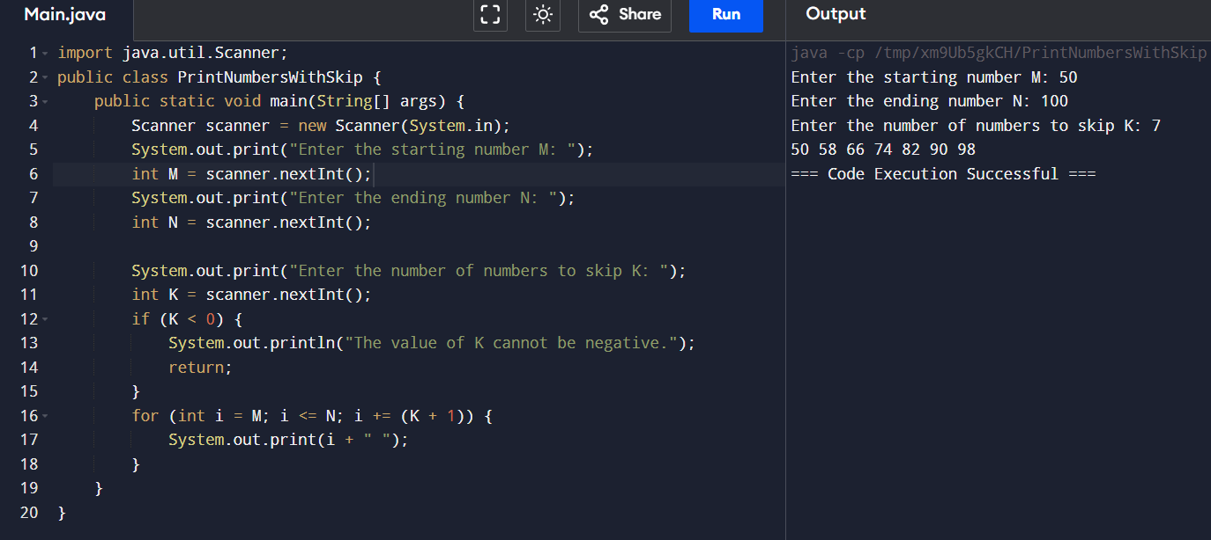

11. Write a program for matrix addition?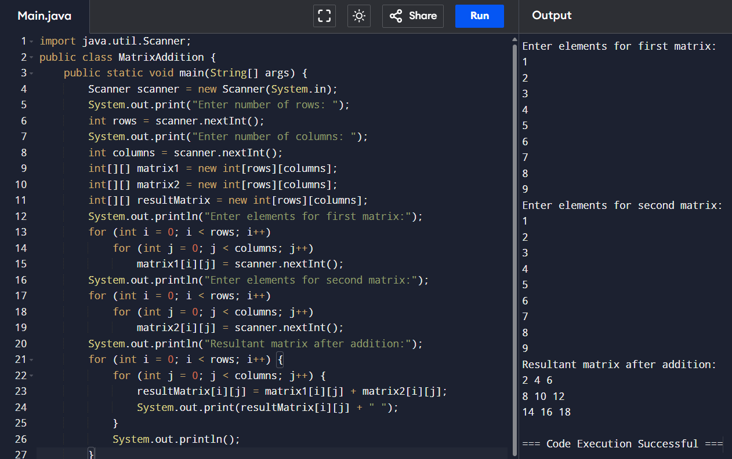

12. Write a program to print rectangle symbol pattern. Get the symbol as input from user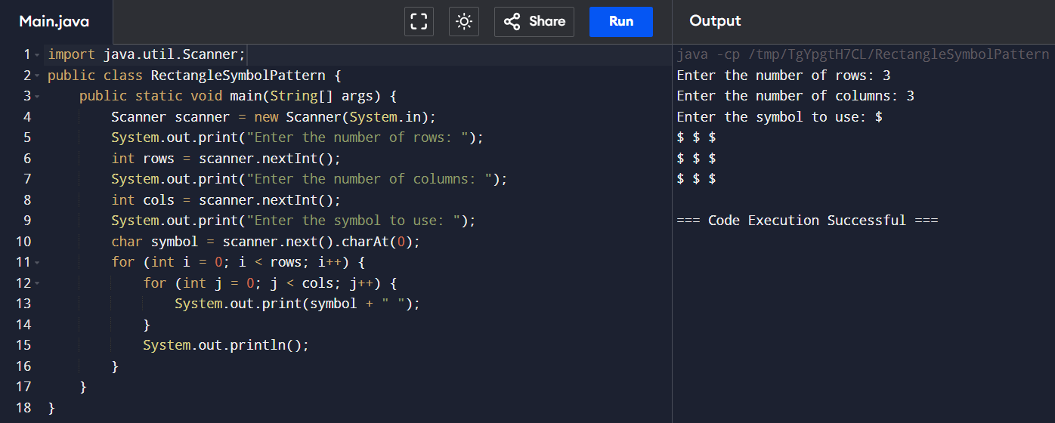

13. Write a program that would sort a list of names in alphabetical order Ascending or Descending, choice get from the user?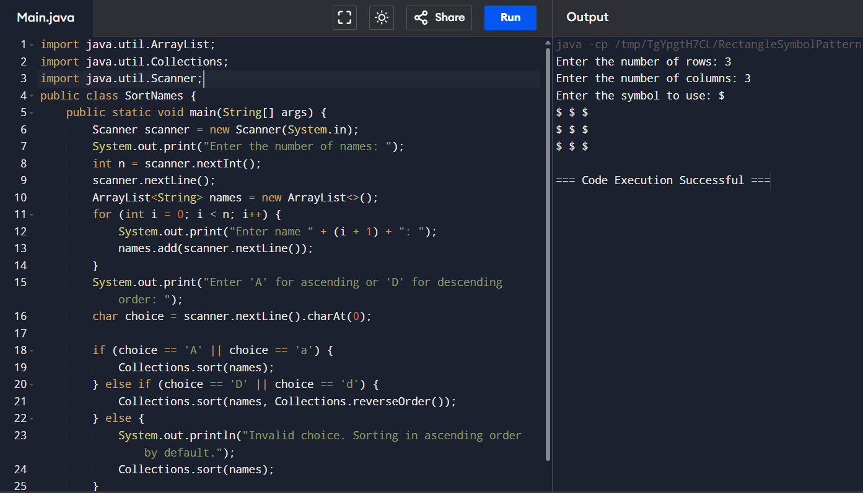

14. Write a program for matrix multiplication?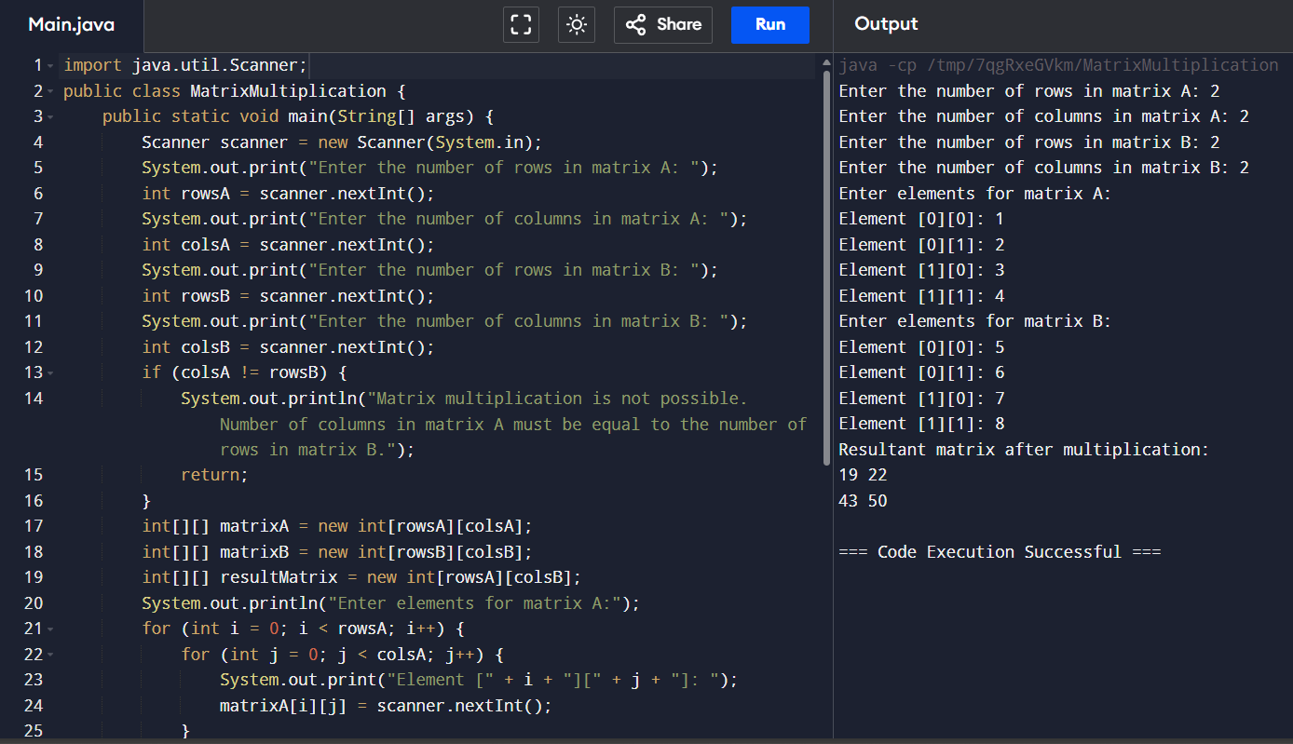

15. Write a program to print the following pattern?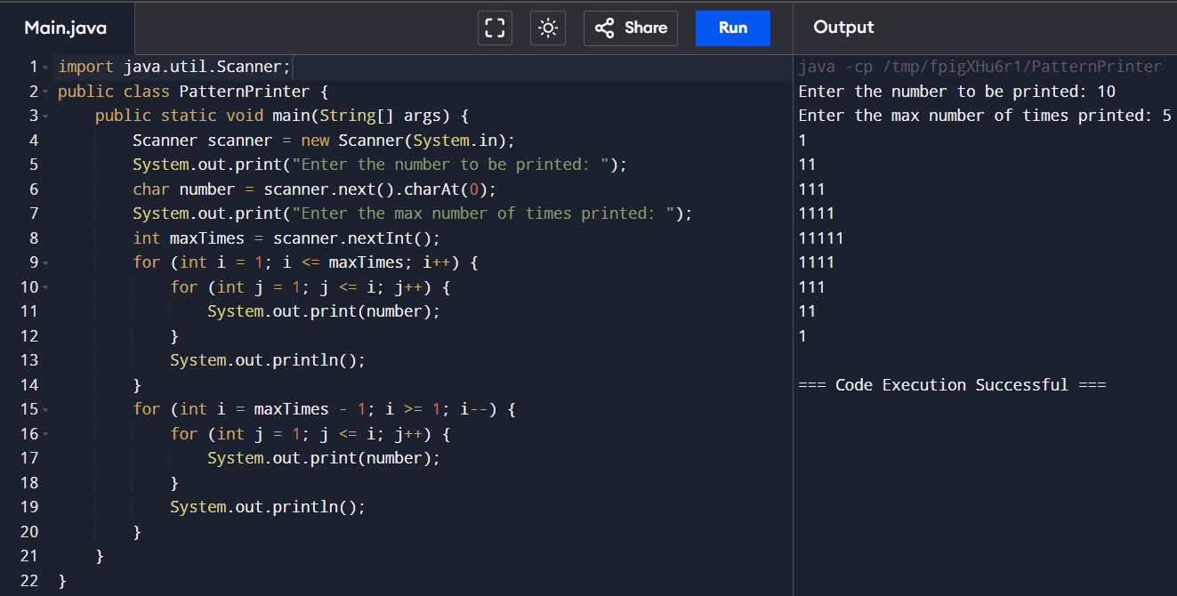

16. Write a program to print the special characters separately and print number of Special characters in the line?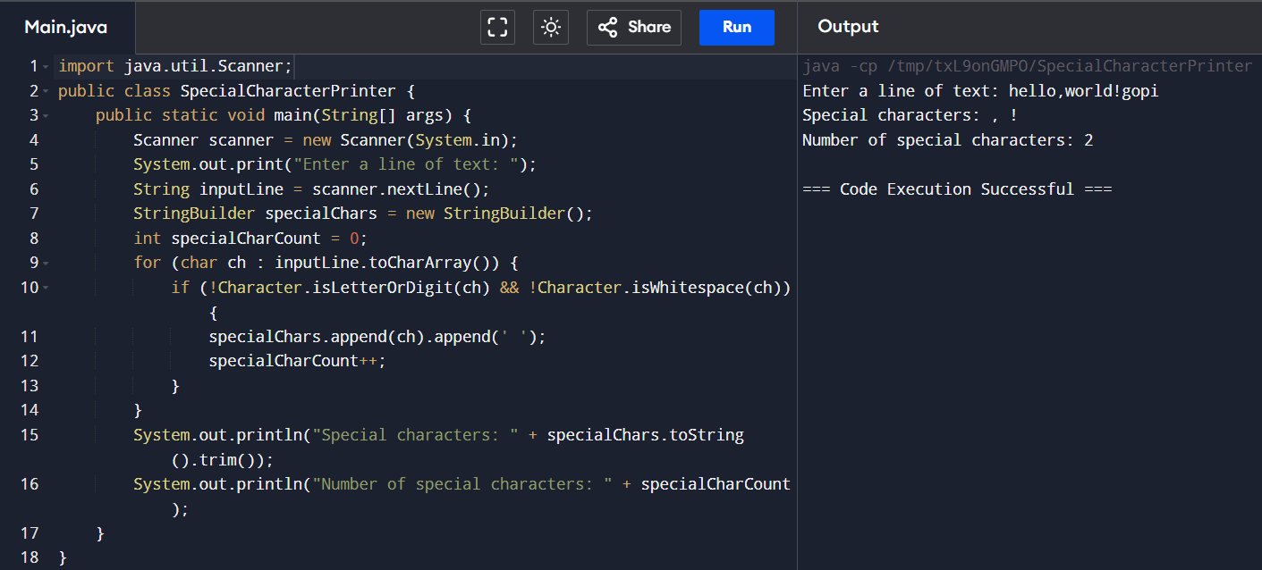

17. Write a program to print all the composite numbers between a and b?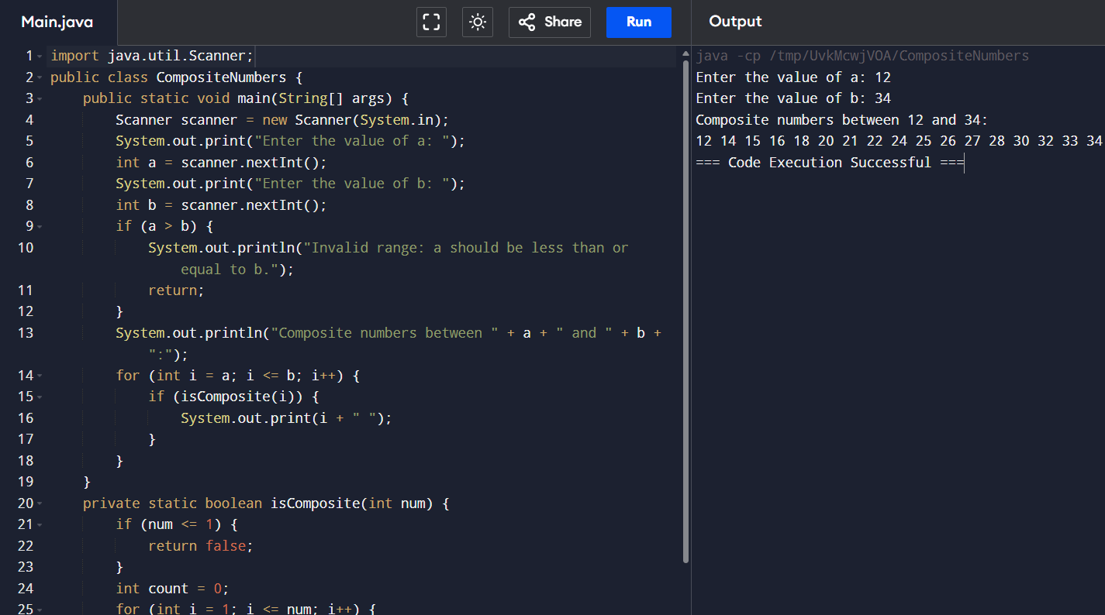

18. Write a program to print the Inverted Full Pyramid pattern?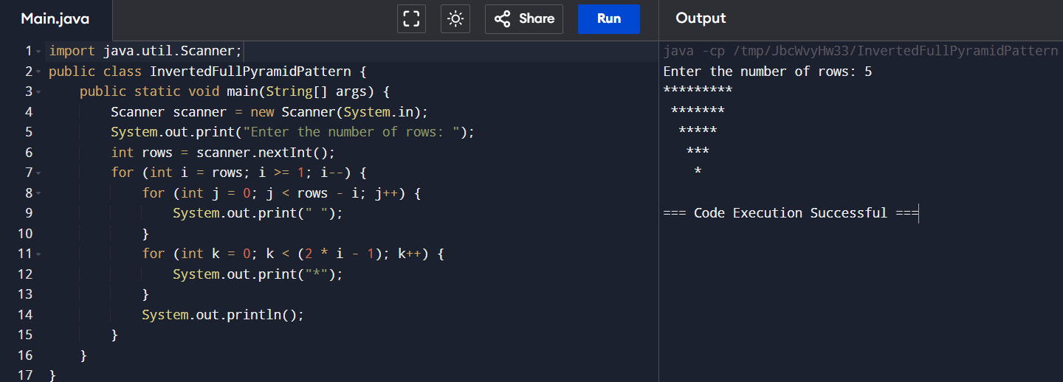

19. Find the Mean, Median, Mode of the array of numbers?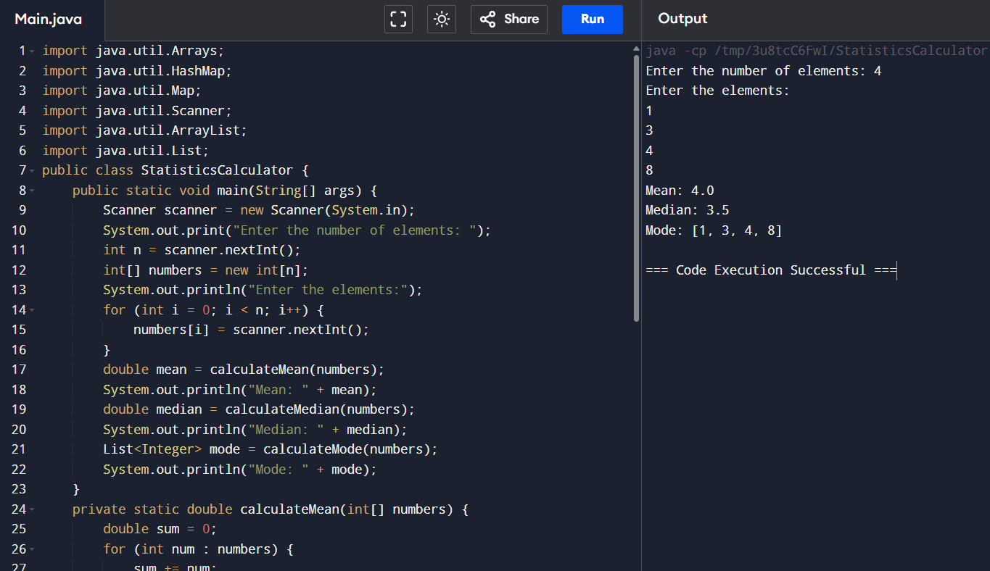

20. Find the factorial of n?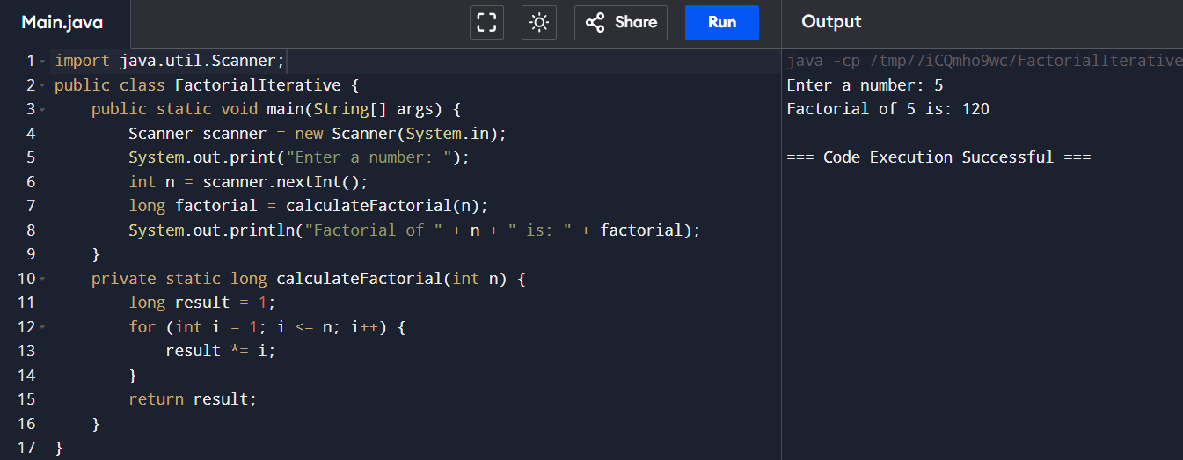

21. Write a program to print the following pattern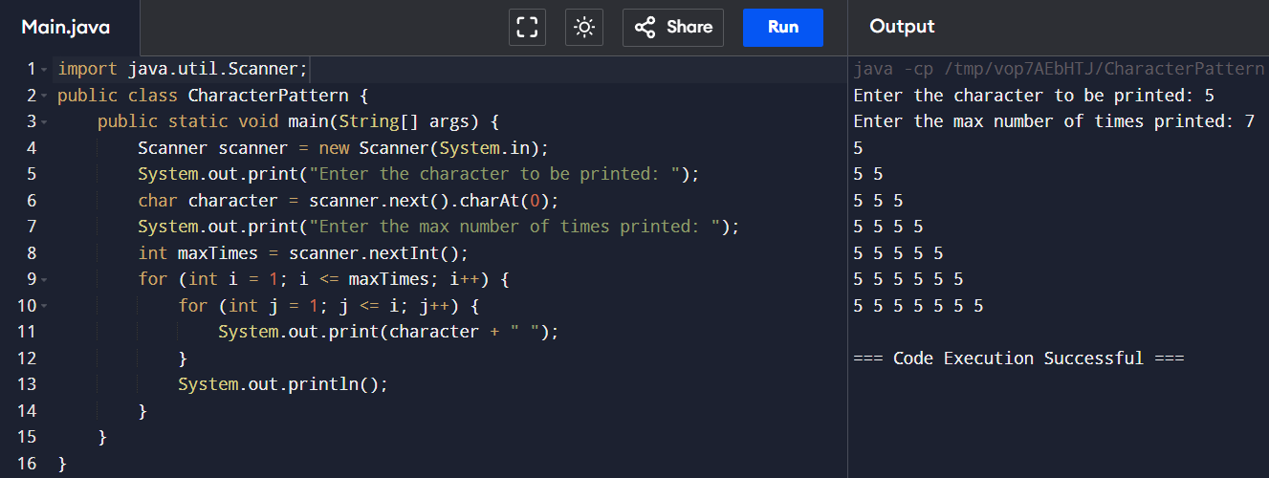

22. Find the year of the given date is leap year or not.

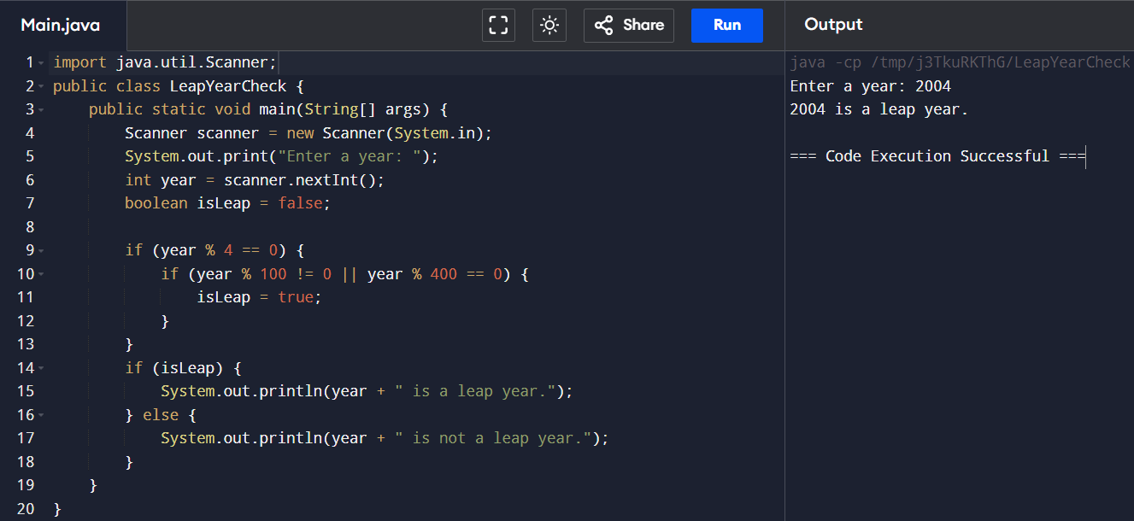

23. Find the number of factors for the given number.

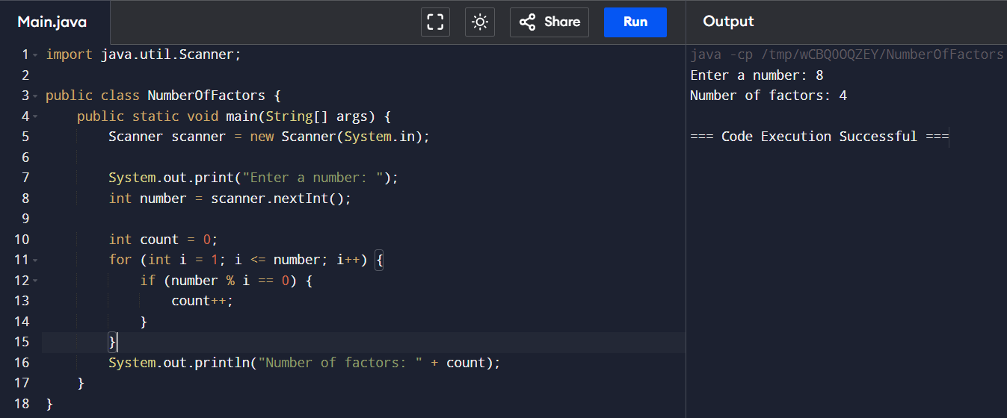

24. Write a program to print the given number is Perfect number or not?

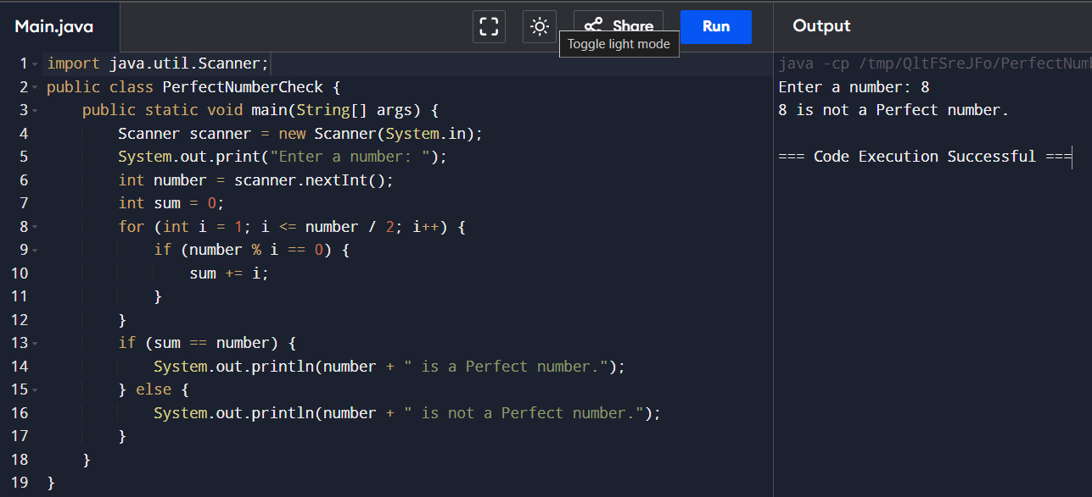

25.Write a program to print the number of vowels in the given statement?

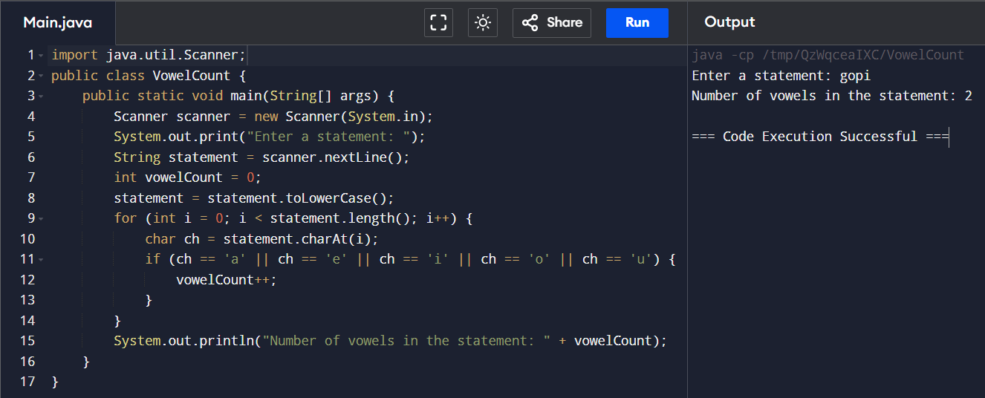

26. Write a program to print consonants and vowels separately in the given word.

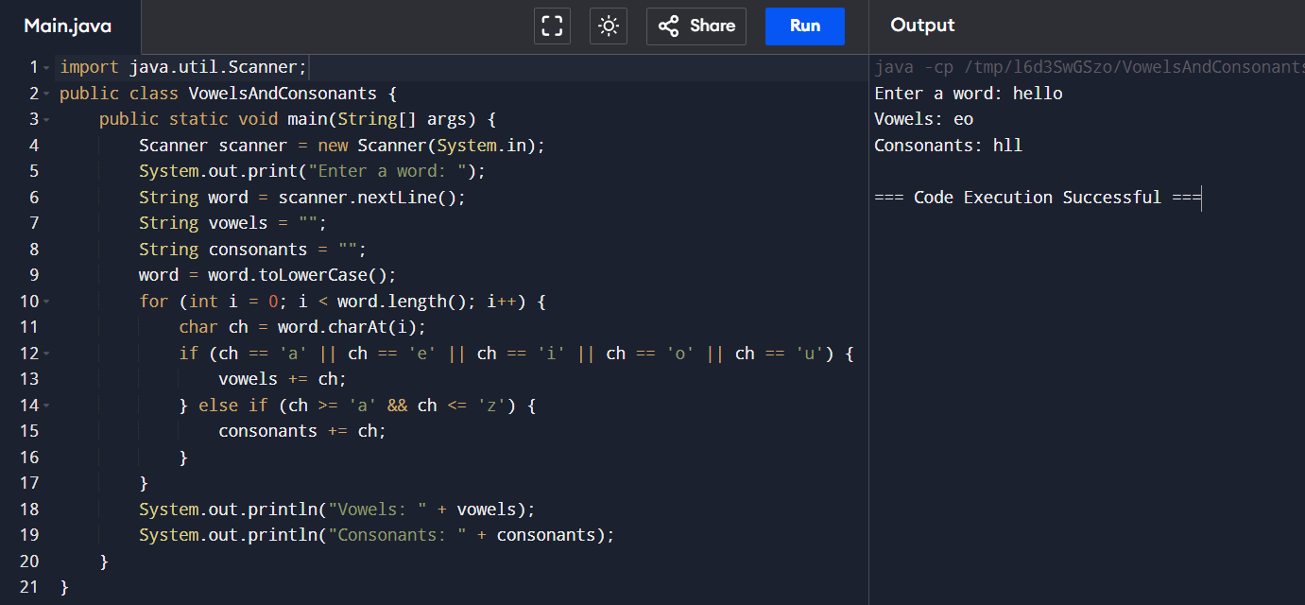

27. Write a program to print the Fibonacci series.

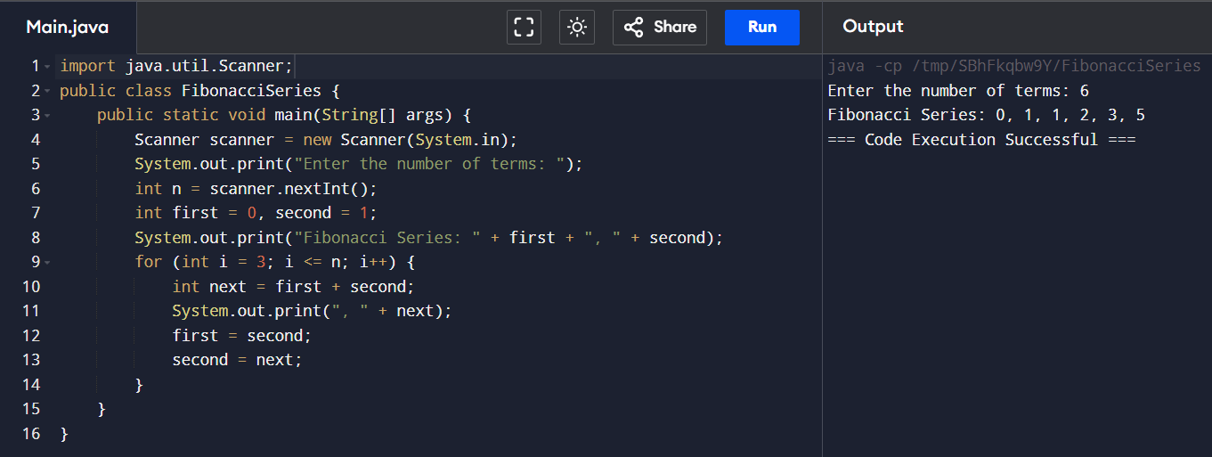

28. Write a program to find the square, cube of the given decimal number 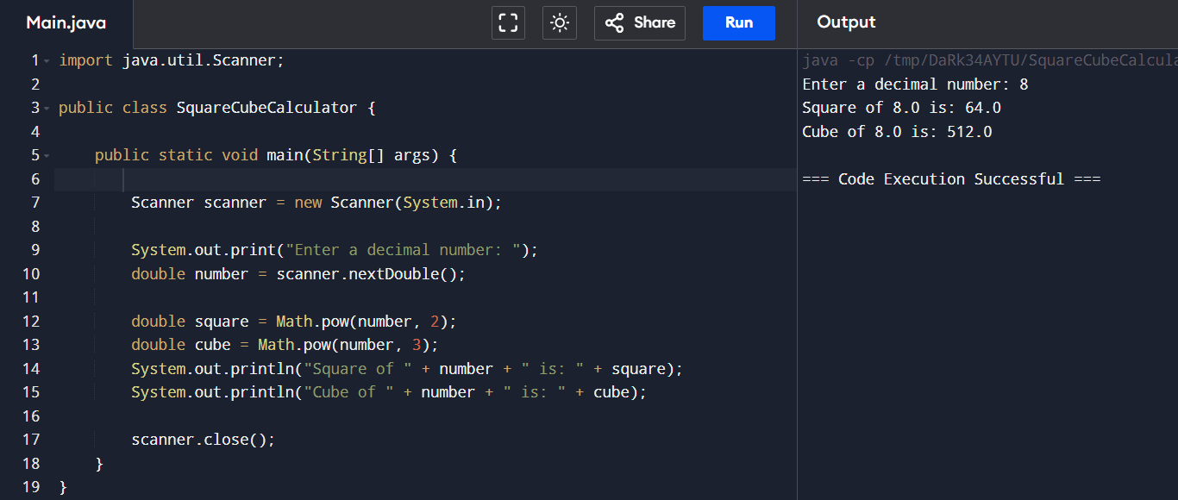

29. . Program to find the frequency of each element in the array 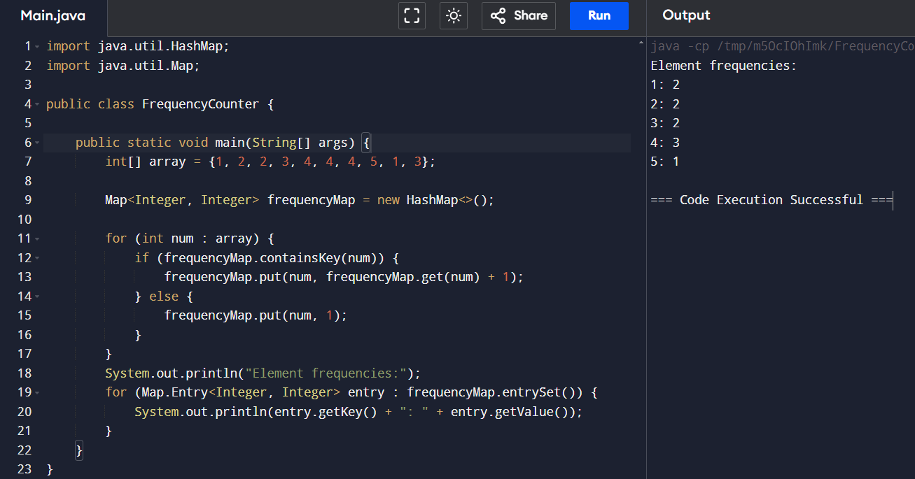

30. Write a program to print the given number is Perfect number or not? 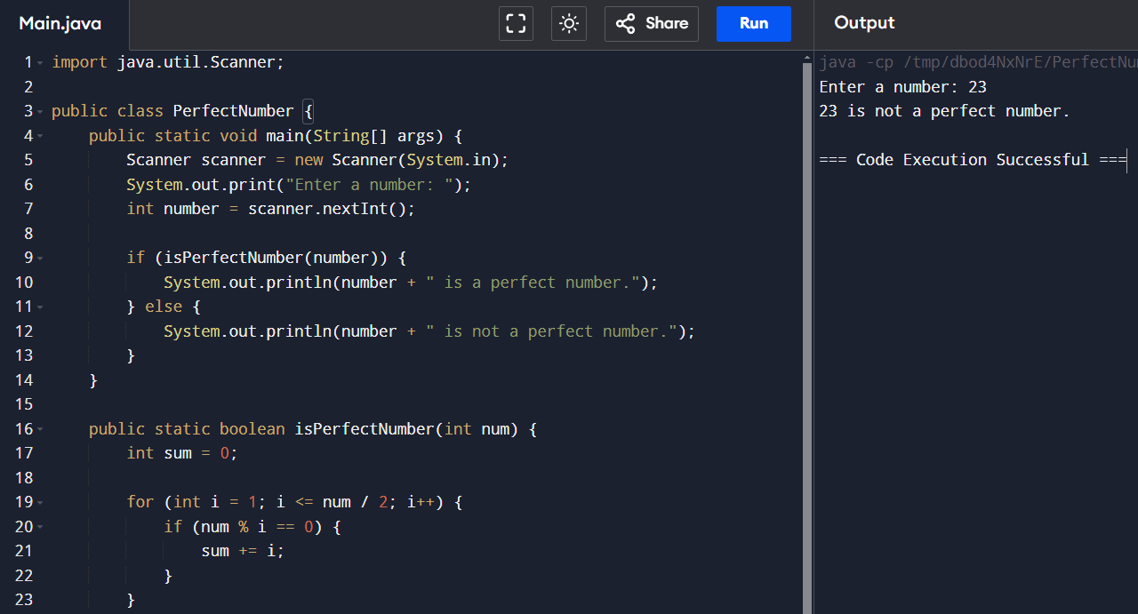

31. find factorial of n? 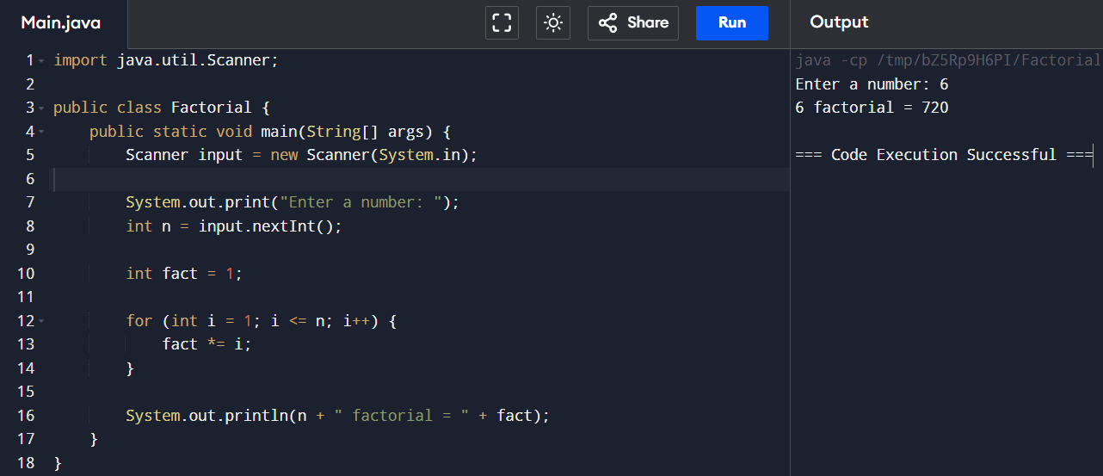

32. Write a program to print the below pattern? 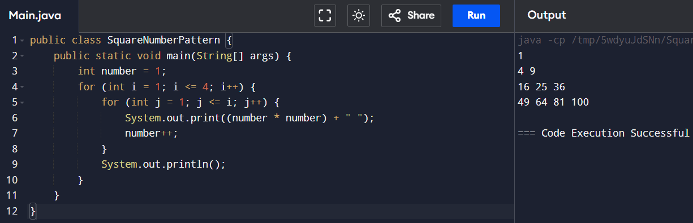

33. Write a program to find the number of composite numbers in an array of elements 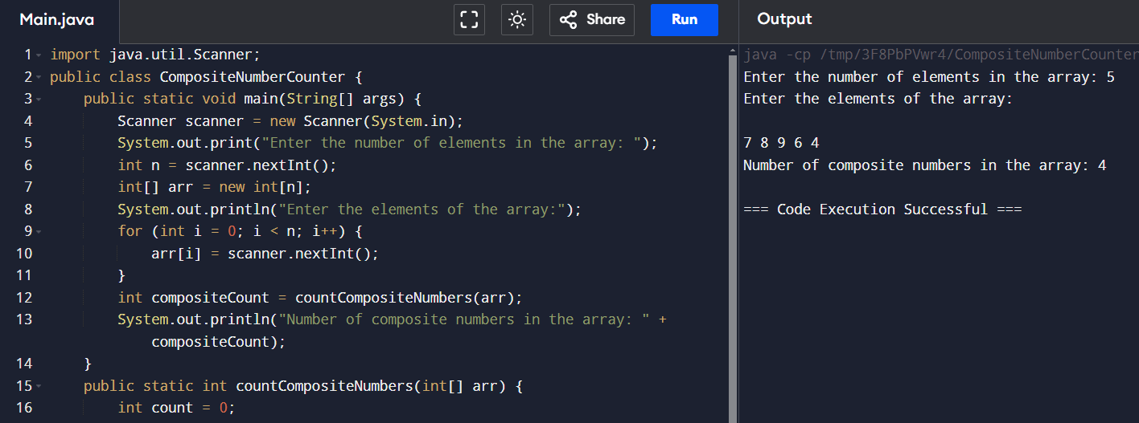

34. . Find the nth odd number after n odd number 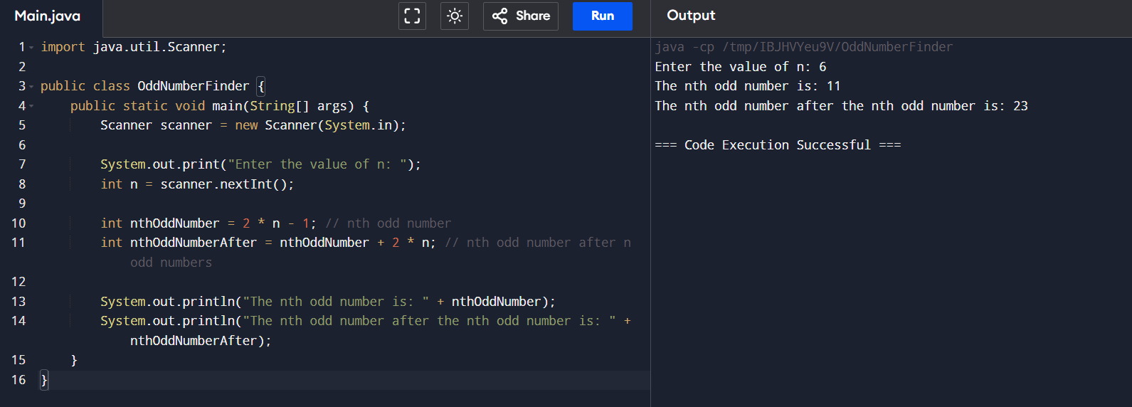

35. Write a program that finds whether a given character is present in a string or not. In case it is present it prints the index at which it is present. Do not use built-in find functions to search the character. 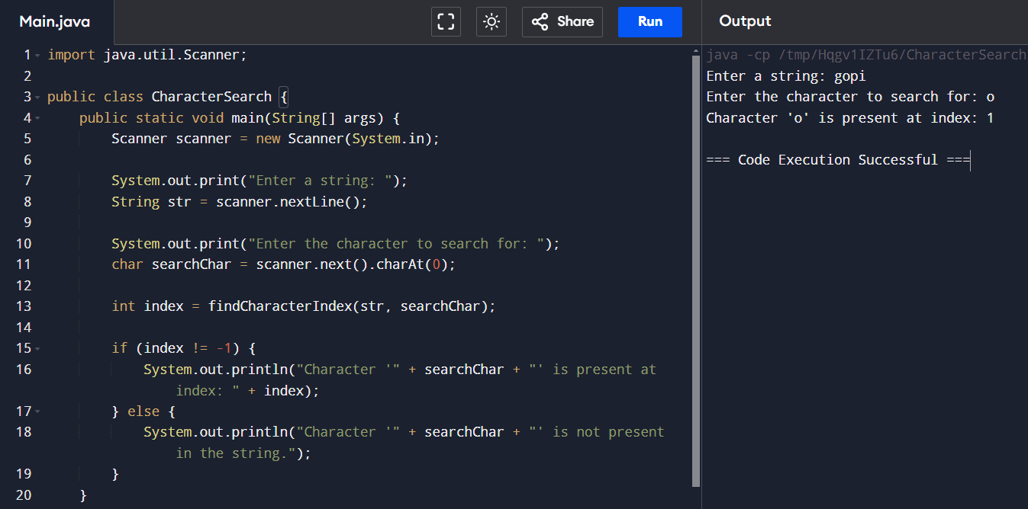

36. Write a program to print the below pattern 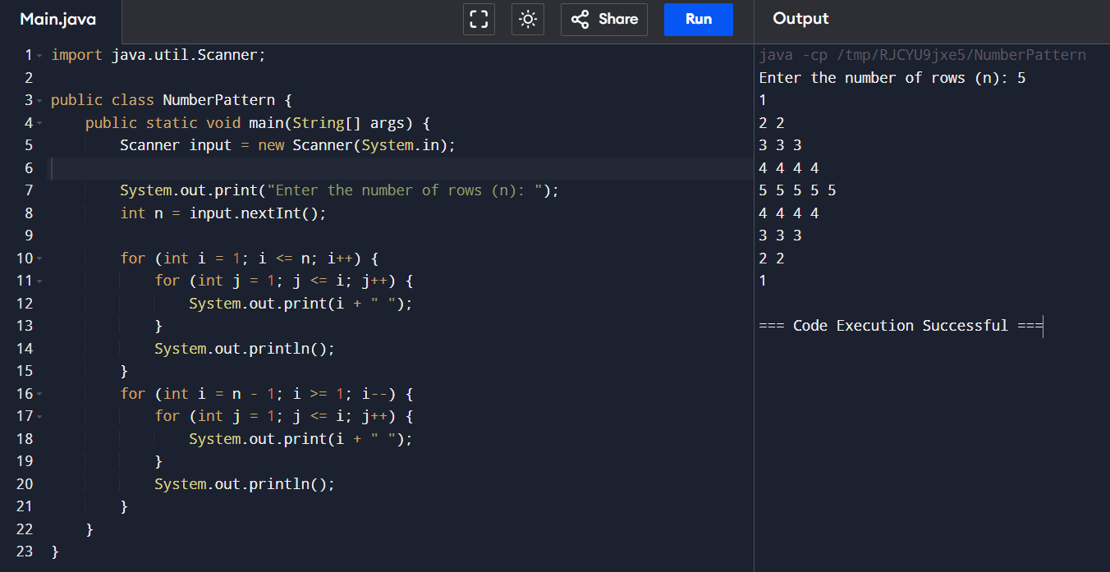

37. Program to find whether the given number is Armstrong number or not 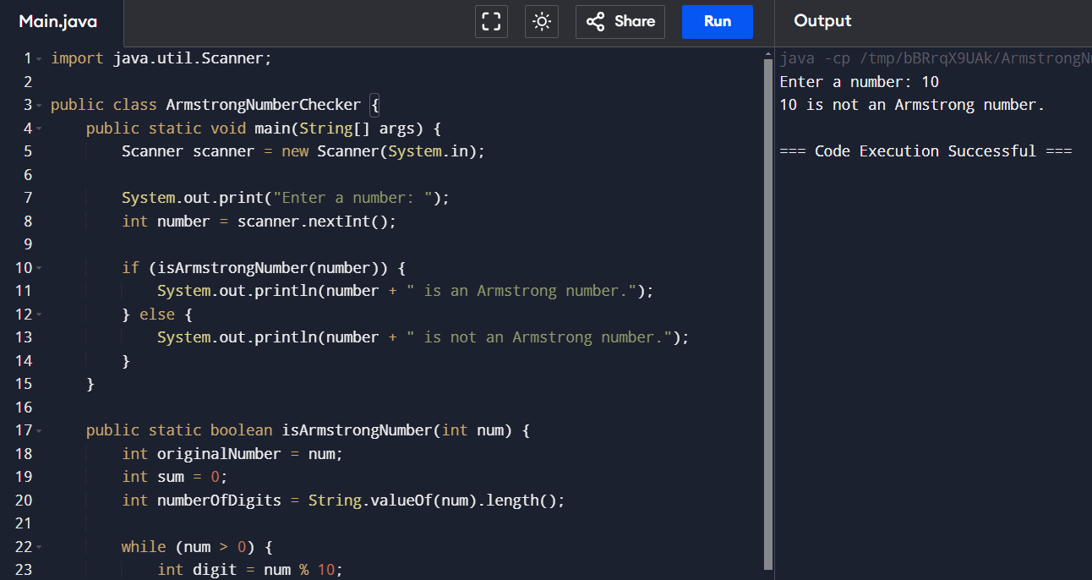

38. Write a program to arrange the letters of the word alphabetically in reverse order 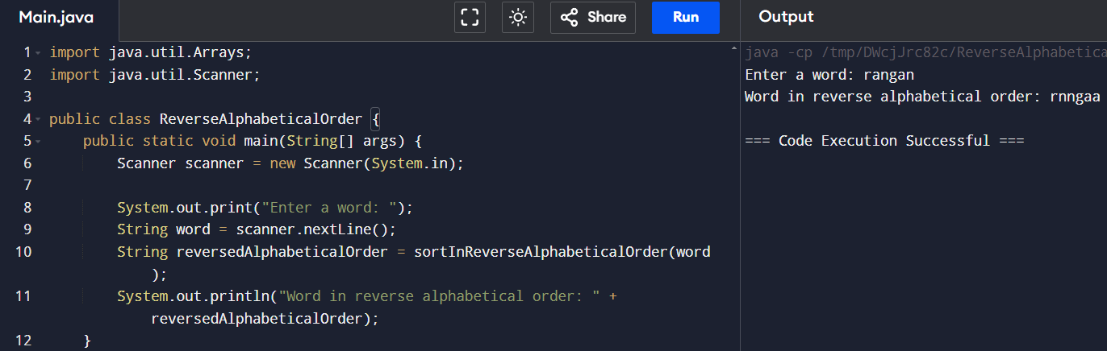

39.Write a program that accepts a string from user and displays the same string after removing vowels from it. 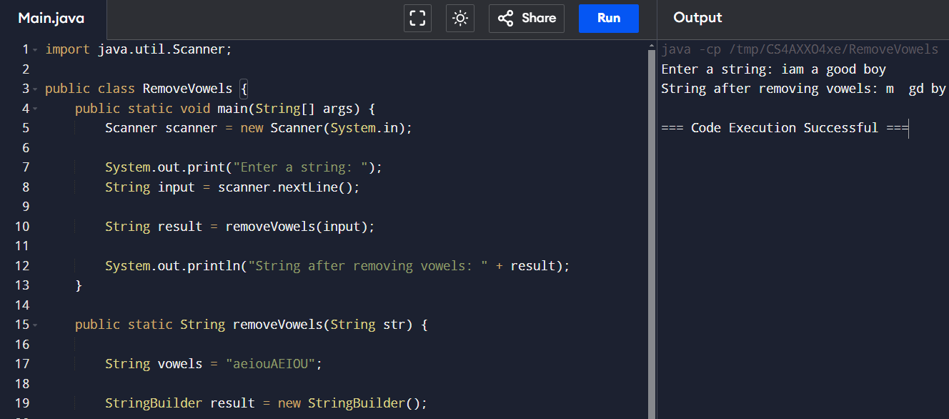

40.Write a program to print hollow SquareDollar pattern? 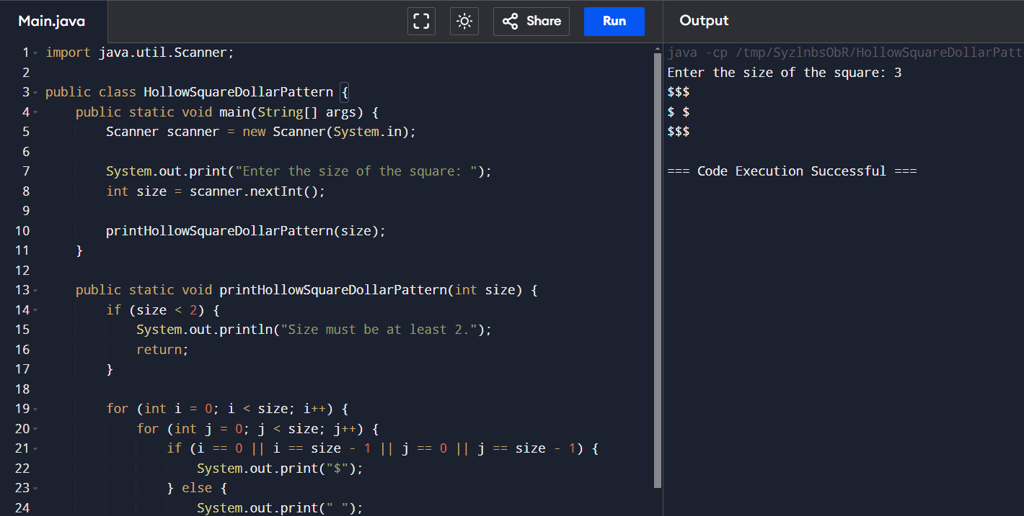

41. Write a program to find the sum of digits of N digit number (sum should be single digit) 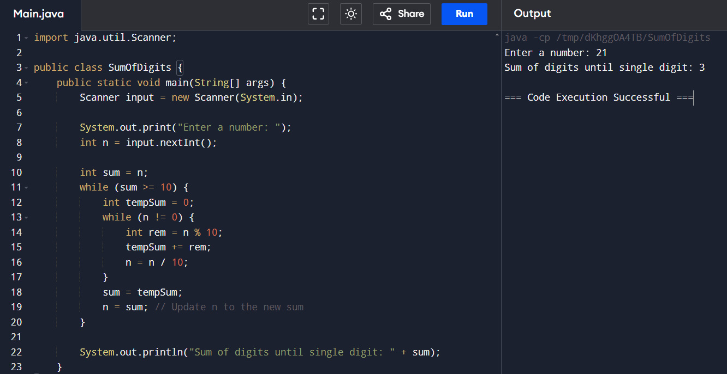

42. Write a program to find the square root of a perfect square number(print both the positive and negative values) 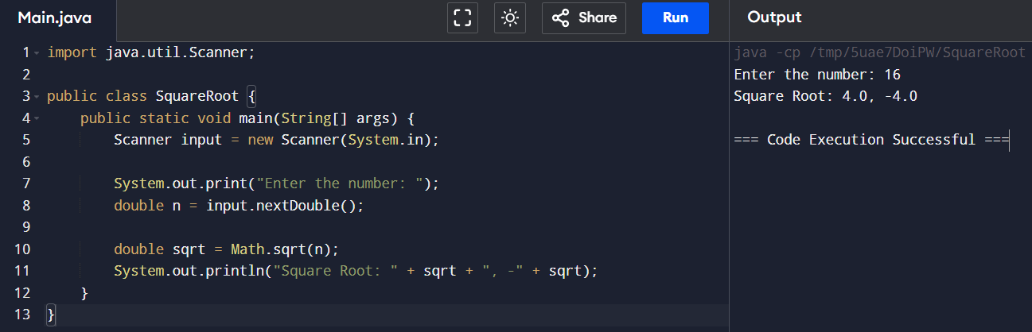

43. Write a program for matrix multiplication? 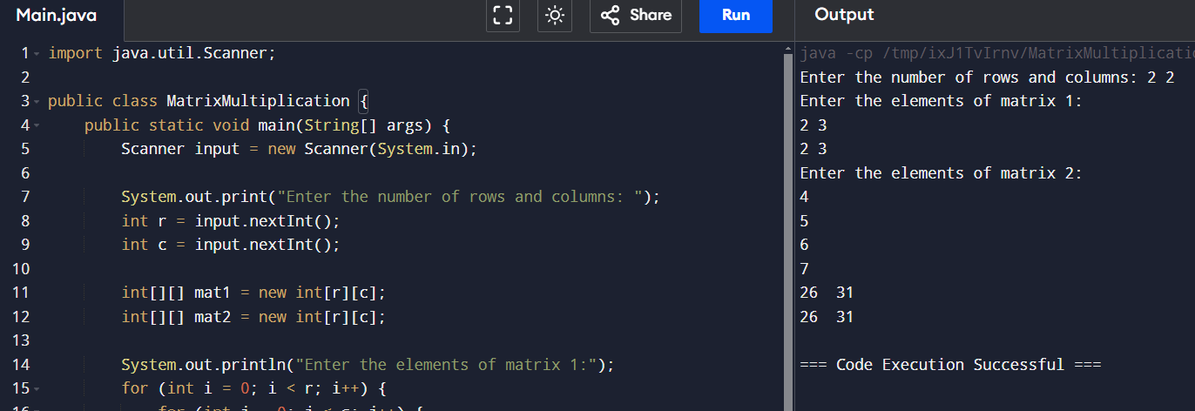

44. Write a program to print inverted pyramid pattern. 